**Raya Summer Training Project**

### Network Topology

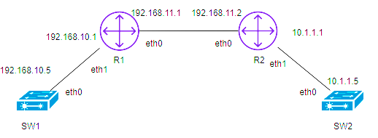

### Project Description

Create your own GitHub Repo to publish python script to configure the above network topology to be in operation by doing the following:

1. Put the Init Configuration on each device (pyserial)
2. Configure each Router with its interfaces with the mentioned Ips (pyserial)
3. Configure each Switch with its Management interface with the mentioned Ips (pyserial)
4. Configure each switch’s ports with their Type and allow Vlans on them. (Netmiko)
5. Configure the route between the routers to allow Network1 to ping Network2 (Netmiko)

### Project Notes

* Use Git and GitHub for script Versions (each step of the 5 must be a version).
* Router 1 is Cisco device and Router 2 is Juniper device.
* Devices must be configured to allow SSH during Init Config.
* Use Netmiko Package to configure the devices.
* Use Ansible to do the configurations as well as a second option for automating the configurations.
* Configuration must be dynamically created (Read data from excel sheets)

“Excel sheets samples attached”.

* Save your created configurations for each router and switch in a one file.